DATAWARE HOUSING AND DATA MINING

ASSIGNMENT 1

GROUP MEMBERS

MUHAMMAD BILAL AHMED (FA20-BCS-041)

MUHAMMAD SALMAN (SP20-BCS-131)

1. **Textual description**

The database is to be designed for an artificial jewelry shop. The information required includes details of supplier, details of products purchased from supplier, description of Products, details of orders like customer name, sold quantity, product name, employee name and order date. Customer places order by physically visiting shop. The shop also keeps record of all employees to monitor the progress of their business.

1. **Normalized ERD and Database diagram from SQL server**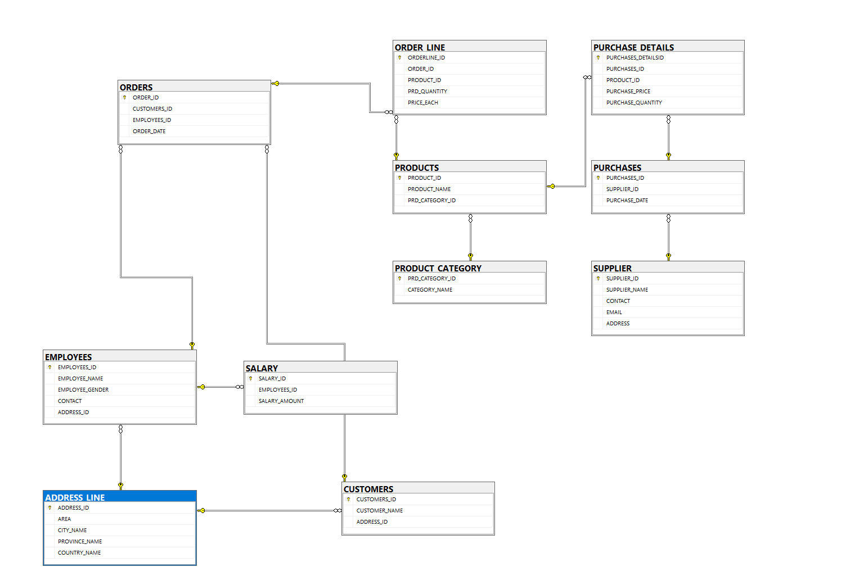
2. **Implementation of ERD in SQL server**

CREATE DATABASE DWDM_PROJECT

USE DWDM_PROJECT

1. **Supplier**

CREATE TABLE SUPPLIER

(

SUPPLIER_ID INT NOT NULL PRIMARY KEY,

SUPPLIER_NAME VARCHAR(50) NOT NULL,

CONTACT VARCHAR(50),

EMAIL VARCHAR(50),

ADDRESS VARCHAR(200),

)

**Bulk Query to insert data from excel file**

Bulk insert DWDM_PROJECT.dbo.SUPPLIER from 'C:\Users\Muhammad Bilal Ahmed\Documents\DW Project\SqlData\SUPPLIER.csv'

with (

fieldterminator=',',

rowterminator='\n',

firstrow=2

)

1. **Purchases**

CREATE TABLE PURCHASES

(

PURCHASES_ID INT NOT NULL PRIMARY KEY,

SUPPLIER_ID INT FOREIGN KEY REFERENCES SUPPLIER(SUPPLIER_ID),

PURCHASE_DATE DATE NOT NULL,

)

**Bulk Query to insert data from excel file**

Bulk insert DWDM_PROJECT.dbo.PURCHASES from 'C:\Users\Muhammad Bilal Ahmed\Documents\DW Project\SqlData\PURCHASES.csv'

with (

fieldterminator=',',

rowterminator='\n',

firstrow=2

)

select * from PURCHASES

1. **Category**

CREATE TABLE PRODUCT_CATEGORY

(

PRD_CATEGORY_ID INT NOT NULL PRIMARY KEY,

CATEGORY_NAME VARCHAR(50) NOT NULL,

)

**Bulk Query to insert data from excel file**

Bulk insert DWDM_PROJECT.dbo. PRODUCT_CATEGORY from 'C:\Users\Muhammad Bilal Ahmed\Documents\DW Project\SqlData\PRODUCT_CATEGORY.csv'

with (

fieldterminator=',',

rowterminator='\n',

firstrow=2

)

1. **Products**

CREATE TABLE PRODUCTS

(

PRODUCT_ID INT NOT NULL PRIMARY KEY,

PRODUCT_NAME VARCHAR(50) NOT NULL,

PRD_CATEGORY_ID INT NOT NULL FOREIGN KEY REFERENCES PRODUCT_CATEGORY(PRD_CATEGORY_ID),

)

**Bulk Query to insert data from excel file**

Bulk insert DWDM_PROJECT.dbo.PRODUCTS from 'C:\Users\Muhammad Bilal Ahmed\Documents\DW Project\SqlData\PRODUCTS .csv'

with (

fieldterminator=',',

rowterminator='\n',

firstrow=2

)

1. **Purchases details**

CREATE TABLE PURCHASE_DETAILS

(

PURCHASES_DETAILSID INT NOT NULL PRIMARY KEY,

PURCHASES_ID INT FOREIGN KEY REFERENCES PURCHASES(PURCHASES_ID),

PRODUCT_ID INT FOREIGN KEY REFERENCES PRODUCTS(PRODUCT_ID),

PURCHASE_PRICE INT NOT NULL,

PURCHASE_QUANTITY INT NOT NULL,

)

**Bulk Query to insert data from excel file**

Bulk insert DWDM_PROJECT.dbo.PURCHASE_DETAILS from 'C:\Users\Muhammad Bilal Ahmed\Documents\DW Project\SqlData\PURCHASE_DETAILS.csv'

with (

fieldterminator=',',

rowterminator='\n',

firstrow=2

)

1. **Address**

CREATE TABLE ADDRESS_LINE

(

ADDRESS_ID INT NOT NULL PRIMARY KEY,

AREA VARCHAR(100),

CITY_NAME VARCHAR(50) NOT NULL,

PROVINCE_NAME VARCHAR(50) NOT NULL,

COUNTRY_NAME VARCHAR(50) NOT NULL,

)

**Bulk Query to insert data from excel file**

Bulk insert DWDM_PROJECT.dbo.ADDRESS_LINE from 'C:\Users\Muhammad Bilal Ahmed\Documents\DW Project\SqlData\ADDRESS_LINE.csv'

with (

fieldterminator=',',

rowterminator='\n',

firstrow=6

)

1. **Customers**

CREATE TABLE CUSTOMERS

(

CUSTOMERS_ID INT NOT NULL PRIMARY KEY,

CUSTOMER_NAME VARCHAR(50) NOT NULL,

ADDRESS_ID INT FOREIGN KEY REFERENCES ADDRESS_LINE(ADDRESS_ID),

)

**Bulk Query to insert data from excel file**

Bulk insert DWDM_PROJECT.dbo.CUSTOMERS from 'C:\Users\Muhammad Bilal Ahmed\Documents\DW Project\SqlData\CUSTOMERS.csv'

with (

fieldterminator=',',

rowterminator='\n',

firstrow=2

)

1. **Employees**

CREATE TABLE EMPLOYEES

(

EMPLOYEES_ID INT NOT NULL PRIMARY KEY,

EMPLOYEE_NAME VARCHAR(50) NOT NULL,

EMPLOYEE_GENDER VARCHAR(10) NOT NULL,

CONTACT VARCHAR(50),

ADDRESS_ID INT FOREIGN KEY REFERENCES ADDRESS_LINE(ADDRESS_ID),

)

**Bulk Query to insert data from excel file**

Bulk insert DWDM_PROJECT.dbo.EMPLOYEES from 'C:\Users\Muhammad Bilal Ahmed\Documents\DW Project\SqlData\EMPLOYEES.csv'

with (

fieldterminator=',',

rowterminator='\n',

firstrow=2

)

1. **Orders**

CREATE TABLE ORDERS

(

ORDER_ID INT NOT NULL PRIMARY KEY,

CUSTOMERS_ID INT FOREIGN KEY REFERENCES CUSTOMERS(CUSTOMERS_ID),

EMPLOYEES_ID INT FOREIGN KEY REFERENCES EMPLOYEES(EMPLOYEES_ID),

ORDER_DATE DATE NOT NULL,

)

**Bulk Query to insert data from excel file**

Bulk insert DWDM_PROJECT.dbo.ORDERS from 'C:\Users\Muhammad Bilal Ahmed\Documents\DW Project\SqlData\ORDERS .csv'

with (

fieldterminator=',',

rowterminator='\n',

firstrow=2

)

1. **Orderline**

CREATE TABLE ORDER_LINE

(

ORDERLINE_ID INT NOT NULL PRIMARY KEY,

ORDER_ID INT FOREIGN KEY REFERENCES ORDERS (ORDER_ID),

PRODUCT_ID INT FOREIGN KEY REFERENCES PRODUCTS(PRODUCT_ID),

PRD_QUANTITY INT NOT NULL,

PRICE_EACH INT NOT NULL,

)

**Bulk Query to insert data from excel file**

Bulk insert DWDM_PROJECT.dbo.ORDER_LINE from 'C:\Users\Muhammad Bilal Ahmed\Documents\DW Project\SqlData\ORDER_LINE.csv'

with (

fieldterminator=',',

rowterminator='\n',

firstrow=2

)

1. **Salary**

CREATE TABLE SALARY

(

SALARY_ID INT NOT NULL PRIMARY KEY,

EMPLOYEES_ID INT FOREIGN KEY REFERENCES EMPLOYEES(EMPLOYEES_ID),

SALARY_AMOUNT MONEY NOT NULL,

)

**Bulk Query to insert data from excel file**

Bulk insert DWDM_PROJECT.dbo.SALARY from 'C:\Users\Muhammad Bilal Ahmed\Documents\DW Project\SqlData\SALARY .csv'

with (

fieldterminator=',',

rowterminator='\n',

firstrow=6

)